WAR AT THE SHORE BASEBALL 2026 TOURNAMENT RULES
(amended 09/1/2026)
The field hotline number is (860) 310-4909. It will be updated at 4pm & 7am.

The 2026 Little League Baseball Rule Book with Guidelines for all general rules will be followed in the War at the Shore Baseball Tournament for 12u and under players on small fields. For example, strike zones, definition of a batter, and re-entry rules are in effect for all age groups. 13u and older will use National High School Federation Rules. changes below shall supersede the rule books. NFHS rule book is available at NFHS.org.


SUMMARY BY AGE GROUP | 7U | 8U | 9U | 10U | 10U 65 | 11U 60 | 11U | 12U | 13u +
Eligible players born after: | 4/30/19 | 4/30/18 | 4/30/17 | 4/30/16 |  | 4/30/15 |  | 4/30/14 | 4/30/13
Bases | 60' | 60' | 60' | 60' | 65’ | 60’ | 70' | 70' | 90'
Mound | 40' | 42' | 46’ | 46' | 46’ | 46’ | 50' | 50' | 60'
Number of innings | 6 | 6 | 6 | 6 | 6 | 6 | 6 | 6 | 7
Bunting | No | No | Yes | Yes | Yes | Yes | Yes | Yes | Yes | Yes
Fake bunt | No | No | No | No | No | No | No | No | Yes | Yes
Tagging up | No | No | Yes | Yes | Yes | Yes | Yes | Yes | Yes | Yes
Infield fly | No | No | Yes | Yes | Yes | Yes | Yes | Yes | Yes | Yes
dropped third strike | No | No | No | No | Yes | Yes | Yes | Yes | Yes | Yes
Balks | No | No | No | No | warning only | No | one warning per pitcher | Yes | Yes | Yes
Leading and Stealing | No | 2nd to 3rd  MUST EARN HOME | All Bases when ball crosses plate |  | All Bases | All Bases when ball crosses plate | All Bases | All Bases | All Bases | All Bases
Championship time limit | None
Official Game | 4 innings
BAT RULES  46/60 fields | Barrel size must be between 2 ¼ - 2 ¾. Players may use USSSA BPF 1.15, or USA Baseball designations.  non composite wood bats. NO Bamboo
BAT RULES  51/75 Fields  (46/65) | 51/75 USA Standards 2 ¾ barrel maximum OR  USSSA BPF 1.15 2 ¾ barrel maximum (All 2⅝ or 2 ¾ diameter bats must be -10 or heavier) OR  non composite wood bats. NO Bamboo NO BBCOR
BAT RULES  60/90 Fields | 13u only USA Standards Bat Rules or USSSA BPF 1.15 must be followed for 90’ fields. USSSA BPF 1.15 bats must feature USSSA BPF 1.15 Certification. All bats must be -8 or heavier for 90’ fields with a maximum 2 ¾ diameter. 13u can also use -3 BBCOR or non-composite wood bats. 14u and older must use -3 BBCOR or non-composite wood bats NO Bamboo for any age.

GENERAL RULES & EQUIPMENT FOR ALL AGE GROUPS:
- Only Team Managers, Coaches, or owners should communicate about teams. Parents must contact their manager for league matters.
- NO seeds, gum, or metal cleats on turf fields or mounds. Failure to follow this rule can result in ejection from park and forfeiture of game.
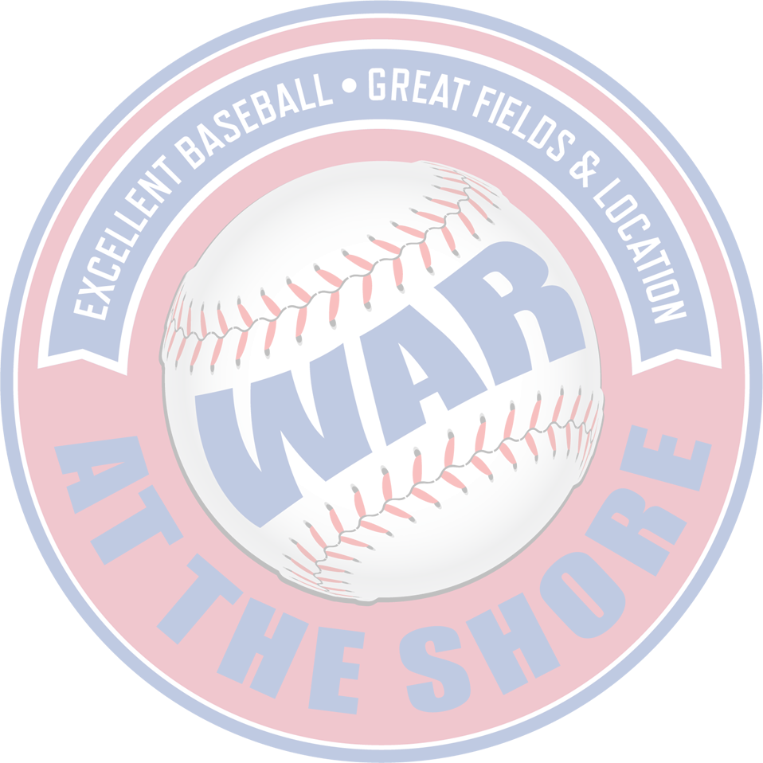
- Conduct of spectators watching the game is the responsibility of the Manager/Coaches. No foul language, smoking or alcoholic beverages are allowed in the entire park.
- Starter players can reenter once, in original spot in lineup order. Subs cannot re-enter.
- Players must wear full uniform at all times, including baseball pants, shirt, and hat. Players without baseball pants or hats are not allowed to play. No shorts are allowed.
- All male players are required to wear athletic supporter with cup.
- Each catcher must wear a protective cup, hockey style helmet mask, chest protector and shin guards during games and while warming up pitchers.
- Baseball shoes must have rubber spikes on the bottom for 12u and under. Metal spikes are not permitted 12 and under or on turf fields. Metal spikes are NOT permitted on Turd Fields. Turf shoes or sneakers only on portable mounds.
- 12u and under USA Standards Bat Rules or USSSA BPF 1.15 must be followed for 60’ 65’ & 75’ fields. USSSA BPF 1.15 bats must feature USSSA BPF 1.15 Certification. All bats must be -10 or heavier for 46/65 & 75’ fields with a maximum 2 ¾ diameter. 13u only USA Standards Bat Rules or USSSA BPF 1.15 must be followed for 90’ fields. USSSA BPF 1.15 bats must feature USSSA BPF 1.15 Certification. All bats must be -8 or heavier for 90’ fields with a maximum 2 ¾ diameter. 13u can also use -3 BBCOR or non-composite wood bats. 14u and older must use -3 BBCOR or non-composite wood bats NO Bamboo for any age.
- Any player found to be using an illegal bat and reaches base shall be called out and ejected from the game. If his turn has not been completed, a warning will be issued, and the bat shall be removed from the game.
- All batters/baserunners must wear helmets. Players who coach bases must wear helmets as well.
- A defensive outfield shall consist of 3 players that must be on the outfield grass. Only 4 infielders are allowed.
- 8u and under: If both managers agree 4 outfielders may be used. In that case Outfielders are prohibited from throwing runners out at first base except for a failed tagging up or fly ball double play
- No coaches are allowed on the field
- Each team will be permitted to bat nine with up to two Extra Hitters or use a Universal batting order.
- Parents are not allowed in the dugout during games. Team managers are responsible for their players & parents at all times.
- No unsupervised bat swinging or ball throwing.
- Bat/Helmet throwing is prohibited and may result in ejection from the game by the umpire.
- If a player gets ejected, it is an out in the it is an out in the lineup unless an eligible sub is available.
- Dropped third strike rule in effect 10u 46/65 and over.
- NO seeds, gum, or metal cleats on turf fields or mounds. Failure to follow this rule can result in ejection from park and forfeiture of games. Turf shoes or sneakers only on portable mounds.
SUPPLEMENTARY GAME RULES:
- Coin flip determines the home team.
- Teams must be ready & available to start a game up to 30mins of listed start times during tournament play.
- Games consist of 6 innings for 12u and underage groups. 7 innings for 13u and older age groups. No game can have an inning start after 2 hours. Extra innings can be played subject to the time limit.
- The game will result in a tie if the score is tied at the end of the time limit and the home team has equal # of at bats to visiting team.
- Games are considered official at the end of the 4th inning for all age groups.
- All teams will abide by 12 after 4, 10 after 5 mercy rules.
Once a team is ahead by 12 runs after the trailing team has batted 4 times, the game is official.
Once a team is ahead by 10 runs after the trailing team has batted 5 times, the game is official.
- Infield fly rules are in effect for all ages except for 7u and 8u.
- Tagging up of all bases including home is permitted for ages 9u and up.
- No fake bunt swing is allowed 12U & under. This is for the safety of the players.
- If a player is injured and cannot return to the game. Their spot in the lineup WILL NOT constitute an out if they cannot bat. Any balls and strikes on an injured batter who must leave the game, will apply to the next batter in the order.
- All injuries must be reported to the War at the Shore Tournament Safety Officer, at safety@warattheshoretournaments.com within 48 hours.

Extra Hitters
1. Teams have the option of using one or two extra hitters according to the following rules and conditions:
(a) A team must have ten or more players prior to the start of the game.
(b) The Extra Hitter (EH) cannot be added after the start of the game.
(c) A team has the option of using or not using the EH.
(d) The EH can be substituted for and is entitled to reentry.
(e) There is unlimited defensive substitution for players in batting order. All players in field must be in lineup. Note: all pitching rules must be followed.
(f) Under no conditions may a player reenter a game in other than his original position in the batting order.

(g) The EH is considered a starting player. If a team elects to use an EH, they must finish the game with a player in that position in the batting order. If an EH must leave a game for any other reason than an injury that the EH has suffered in that game, and there is no replacement for that EH, every time that EH is due to bat it becomes an automatic out.
2. The use of DH is prohibited (12u and under).
3. Universal batting order is permitted. If a player is injured in the game an automatic out will NOT be applied.
4. If the Universal batting order is not used, a starting player who has been removed from the game, may be inserted once under the following conditions: a) the player must return to the original spot in the batting order, b) only a starting player is eligible to be reinserted and he may only be reinserted once per game, c) the player does not have to return to his original defensive position, and d) a pitcher after being removed from the game or remaining in the game in a different position cannot return to the game at any time as pitcher.

ELIGIBLE PLAYERS BY AGE GROUP:
MANDATORY FOR ALL AGE GROUPS - PROOF OF AGE (copies of birth certificates and any valid photo id from any school or any local, state, or federal government OR A valid Validage Sports ID card OR A NATIONAL SPORTS ID Card OR an Ankored Age Verification account) THIS IS FOR ALL PLAYERS ON YOUR ROSTER MUST BE AVAILABLE UPON REQUEST. TEAMS CAN ASK FOR PROOF OF AGE FOR ANY PLAYER. IF PROOF OF AGE CANNOT BE GIVEN THEN THAT PLAYER IN QUESTION COULD RESULT IN NOT BEING ABLE TO PLAY IN THAT GAME OR A FORFEIT.
SCHOOL AGE EXMPTIONS:
Only two grade exemptions per team are permitted for players of the same birth year born before May 1st, but eligible only if born on or after January 1. Exemption players can join one roster only; if listed on another team, they become ineligible. (note: does not include intramural teams)
PLAYING WITH EIGHT PLAYERS:
- A team may start the game and play with eight players. When playing with eight players, the vacant slot in the batting order is a MANDATORY out. If a ninth player arrives, he may be inserted into the game at the bottom of the lineup and will be an eligible batter the next time he is up in the order.
- In the event of an injury that happened during the game to the ninth player, the automatic out will not apply.
- Additional players who arrive during the game will be placed at the end of the batting order for teams that selected the universal batting order.
PITCHING RULES:
- There are no pitch count rules. However, we encourage the use of the MLB pitch-smart guidelines. It is the responsibility of the individual team officials to ensure the well-being of their pitchers.
- Distance of the pitcher’s rubber to Home Plate shall be 42’ for 7u & 8u, 46’ 9u & 10u & 11u 60,51’ for 11u & 12u and 60’ 6” for 13u and older.
- Balks - No balk warnings for the 12U and over divisions. One warning per pitcher in the 11U 50/70' divisions. 10U 46/65 will receive warnings only. All balks are a "dead ball". No runners can advance on any balks called by the umpire.
- Pitchers are allowed to fake a throw to the third base, commonly known as “fake-to-third, throw-to-first.”
- Mound Visits – 12u and under; The manager is permitted to visit the mound twice in an inning and a maximum three times per game without removing the pitcher. (this is per pitcher) Injuries to the pitcher do not count as a mound visit. 13u and up: NFHS (National Federation of State High School Associations) baseball, a team is allowed three charged defensive conferences per game. A charged conference is a visit to the pitcher by the coach or manager where the pitcher is not removed from the game. If a team uses all three conferences and then visits the mound again, the pitcher must be removed from the game. In extra innings, one additional conference is allowed per extra inning.
- Hit Batters –12u and under Any pitcher that hits three batters in a inning or five in a games must be removed from the game as a pitcher. He may not return as a pitcher for the rest of that game.
- Warm-up Pitches before an Inning: 8 warm-up pitches per inning for any new pitcher, 5 warmup pitches after that. This will keep the games moving and limit overworking players’ arms.
- Pitchers cannot use a first basemen’s mitt.
- A pitcher after being removed from the game or remaining in the game in a different position cannot return to the game at any time as pitcher.
- 8u and under: Walks: The first three walks in an inning will consist of 4 balls. After three walks, walks will consist of 6 balls for the rest of that inning. This rule can be waived if both coaches agree.
STEALING / BASE RUNNERS:
- Bases will be set at 60’ for all 10u and underage groups, 70’ for 11u and 12U, and 90’ for 13u and older.
- 12u and under: There is no courtesy runner permitted. The speed up rule, for catchers only, may be applied if there are two outs. This rule is to be applied at the manager’s discretion. (Note- the re-entry rule may be used in a base-running situation.) A player must have been the catcher in the previous ½ inning in order to have a runner take his place.
13u and up: Under National Federation of High School (NFHS) baseball rules, a courtesy runner can be used for the pitcher or catcher of record. The courtesy runner must be a player who has not yet entered the game as a batter or defender. The same courtesy runner cannot be used for both the pitcher and the catcher. A courtesy runner is for the position of pitcher or catcher, not a specific player, and a courtesy runner who has already run for that position cannot run for the other position. If a courtesy runner is injured or ejected, another suitable player can be used as a courtesy runner. See NFHS rules.
- No base runner is permitted to “barrel” into another player. Base runners must slide, give himself up or go around the defensive player or they will be called out and will be ejected from the game.
- For 8U, 9U/10U/11u 60, a runner may attempt to steal the base after the pitch crosses home plate. If the runner leaves base early, the team will be warned, and the runner will return to the original base. All other runners on the warned team will be called out after the first warning.
- No base runners 10U AND UNDER can slide headfirst without penalty of being called out. Headfirst slides back to base are allowed.
- 11U & OLDER 50/70 base runners can lead and attempt to steal all bases at any time.
- 11U 50/70 & OLDER batters become base runners on a dropped third strike by the catcher when applicable.
- 8U: NO STEALING HOME- A PLAYER MAY INHERIT HOME PLATE ON CONTINUOUS PLAY ON A BATTED BALL OR BY BEING FORCED IN BY A WALK. IF A PLAYER ROUNDS 3RD BASE AND IS TAGGED OUT HE IS OUT. IF A PLAYER ROUNDS 3RD BASE AND MAKES IT HOME SAFELY HE IS TO RETURN TO 3RD BASE- NO PENALTY.
- 8U: Base runners may attempt to advance on overthrows of 1st, 2nd or 3rd bases on a hit ball only.
- 8u: Base stealing is allowed at this level. Unlimited steals from 2nd to 3rd per inning Defensive players are instructed to not block the base from the base runner. No stealing of 2nd.
not block the base from the base runner.
- 8u: Coaches will teach base runners to slide, give themselves up or go around the defensive player or they will be called out. If this occurs twice during a game, the coach must sit the player down for the remainder of the game.
- 8u: The ball is considered “dead” on a throw from the outfield to the infield and is in the possession of an infielder. Once ball is secure in infield, runner must go back to previous base unless he is more than half-way to next base. Instruct outfielders to throw the ball into the nearest infielder. If the runner is more than half way to the next base, the player may proceed to that base. Do not let the player’s run wild on the base paths.

UMPIRE / GROUND RULES:
- Ground rules and divisional rules will be discussed between the Managers and Umpires prior to the start of the game. Lineups and substitutions players must be exchanged prior to the game.
- Umpires are to be respected. Umpires will not tolerate foul language from players, coaches or parents.
- If a question arises pertaining to a disputed call or rule interpretation, the team manager, and only the team manager can discuss with the calling umpire.
- Only the umpire can grant timeout to a player once the play is considered over by the umpire. Managers can instruct the player to call a timeout that the umpire may elect to grant.
- If a manager, coach, parent or player is ejected from a game they must leave the field immediately. Failure to do so will result in forfeiture. Note: an ejected person should not be able to be seen or heard by the umpire

PROTESTING A GAME:
- The only person who may protest will be the team manager or person in charge of the team.
- The only grounds for protest is a decision based on the interpretation of the rules, or the use of an ineligible player/bat.
- THE PROTEST MUST BE MADE IMMEDIATELY PRIOR TO THE RESUMPTION OF PLAY AND INDICIATED TO THE UMPIRE(S) IN A HIGHLY VISIBLE MANNER. IN THE CASE OF AN INELIGIBLE PLAYER, THE PROTEST MUST BE MADE BEFORE THE FINAL OUT OF THE GAME. PLAY MUST BE STOPPED.
- The Tournament Director will make the decision whether the protest is upheld. If so, the game will be resumed from the point of the protest, except in the case of an ineligible player where a forfeit will result.

WEATHER CONDITIONS / LIGHTNING:
- Assume all games will be played if the weather is questionable unless called or emailed by a Tournament representative. Safety of the players is of primary concern.
- Poor weather prior to the start of the game – Managers may also call the field hotline number at 516 502 7705 or access the Tournament website at www.lihotstovebaseball.com to find out if fields are open. The hotline will be updated by 7:00am on weekends and by 4:00pm during the weeknight games.
- Poor weather after the start of the game – Umpires to determine if fields are in playable condition and will stop games if player safety is at risk. If thunder or lightning is heard or seen nearby during a game, the game is to be stopped immediately. The game may resume after twenty continuous minutes without thunder or lightning. The umpire will call the game after three thunder or lightning delays. Safety is of primary concern.
- It is an official game after four innings if the game is called for darkness or any other weather condition. The trailing team must bat the required number of times for the game to be official. The game will revert to the last completed inning if the game is called in the middle of an inning.

INJURY/ILLNESS

Any player removed from a game for illness/ injury may not reenter. Any player who receives an injury (other than superficial) or becomes ill, etc., may not play any more that day. Note that swelling, lacerations, etc. will remove an injury from the superficial status. A player who has been rendered unconscious during a game shall not be permitted play in subsequent games without written authorization from a physician. This authorization must be supplied to the Tournament prior to the player returning to play. When a player is removed from a game for an injury / illness, all substitution rules apply. In the event of an injury that happened during the game, the automatic out, as per Rule “O”, above, will not apply. All injuries must be reported within 48 hours in writing to the Tournament.
PLAYOFF RULES:
- STANDARD TIME LIMITS ON ALL PLAYOFF GAMES EXCEPT CHAMPIONSHIPS.
- California tie breaker in effect in 9th inning
- NO TIME LIMIT FOR CHAMPIONSHIP GAMES. MERCY RULE IS STILL IN EFFECT
- During playoffs higher seeded teams are the home teams

The California tie breaker rule is a baseball rule that's used to break ties in playoff or championship games. The rules are as follows:
- The batting order remains the same as it was in the previous inning.
- The visiting team's last batter to make an out is placed on second base.
- The umpire sets the out count to one.
- The inning plays out until the third out is made.
- The home team repeats the process.
- The team with the most runs wins.
- If the teams are still tied after the first round, a second round is played with the runner on third base.
- If the score is still tied, the team that was ahead in the last complete inning where the score was not tied wins.
TIEBREAKER RULES:
- When two teams within a division have identical win-loss records, the winner of the head-to-head competition between those two teams shall advance.
- If both teams have not played head-to-head, the team with the least number of runs allowed in all games played will advance.
When three or more teams within a division have identical win-loss records, the following will apply:
Head-to-head results are only applicable if all of the tied teams played each other
- The least number of runs allowed by a team in all games played will advance that team. If a second place team is required revert back to number 1.
- If still tied, a coin toss by the league
Note: we do not use run differential.

Example:
All teams are tied with a 1-1 record. The team with the lowest runs against becomes the 1 seed. Now that the tie is broken for seed1, we now have a new group of tied teams. You now revert to head-to-head between the remaining teams tied. Once that is broken, you continue that process until you have reached the number of teams needed to make up bracket. As you can see below, Team A wins the lowest RA, now between B and C, even though B gave up more runs, they beat C head-to-head. this process is followed with 3 or more teams tied.
Team A(W) vs Team B(L)
Team A(L) vs Team C(W)
Team B(W) vs Team C(L)
Team A: 7 RA
Team B: 15 RA
Team C: 8 RA

CODE OF CONDUCT
The primary interest of this Tournament is fairness and that the players on the field decide the outcome of the game. In order to ensure that the principles of sportsmanship, fair play, skill development, and mutual respect among players, managers, coaches, umpires and spectators are the primary considerations governing competition in the Tournament, the following Code of Conduct has been established and adopted.

- No use of abusive language or profanity, humiliating remarks, and/or gestures of ill temper, and physical assault upon another player, coach, manager, umpire or Tournament official at any time.
- A physical assault upon another player, coach, manager, umpire or Tournament official by a manager coach or parent of a player will result in the team’s removal from the tournament.
- Respect the manager, coaches and players of the opposing team and demonstrate appropriate gestures of sportsmanship at the conclusion of every game.
- Respect the umpires. The team’s manager may address the umpires during the game but only within the provisions of the rules and in a courteous, respectful manner. Parents may not address the umpires.
- No use of alcoholic beverages, tobacco products or other illegal substances
- Cheer for team in a positive, supportive manner, refraining at all times from making hostile, negative, or abusive remarks about the opposing team.
- Field areas should be kept clean and free of litter. Equipment must be kept in the dugout or away from the playing field.
- Demonstrate appropriate gestures of sportsmanship at the conclusion of a game, win or lose.
- Realize, accept, and practice the principle that a reputation is built not only on its playing ability, but also on sportsmanship and courtesy.
- If a Parent/spectator is ejected during a game, the child/player of said parent/spectator will be ejected as well.
- All coach ejections may be subject to one game suspension.

Improper conduct on the part of managers, coaches, players or spectators may result in expulsion from the game/practice facility, or in extreme cases, forfeiture of the game. The Tournament reserves the authority to discipline managers, coaches, players or spectators during the course of the season for conduct deemed detrimental to the good order of the Tournament. Such actions may include warning, suspension or termination.

